JESSICA PLEASE EMBED HIGHLIGHTED VIDEOS

Indirect Object Pronouns
 | singular | plural
1st person | me me | nos us
2nd person | te you | os-you plural informal
3rd person | le him/her/you formal | les them/you plural formal

Description
An indirect object is a person who receives the action of a verb indirectly; it says to whom or for whom something is done. In Spanish the indirect object is usually preceded by the preposition a and in English by the preposition to. If there is an indirect object in a sentence, it will usually be accompanied by the indirect object pronoun. The indirect object pronoun must match the person and number of the indirect object. In the sentence below, los hijos is the indirect object, accompanied by the pronoun les; both of which are third person plural.
Es más difícil aquí porque aquí les dan más privilegios a los hijos.It’s harder here because here they give children more privileges.
https://www.coerll.utexas.edu/spintx/player/571/?start=15&end=23

Also, the indirect object pronoun may used by itself to replace an indirect object. For example, a los hijos can be removed from the previous sentence to resulting in:
Es más difícil aquí porque aquí les dan más privilegios.It’s harder here because here they give them more privileges.

Placement
There are two places where indirect object pronouns can be placed.
- Before a conjugated verb
- Attached to the end of the verb, ONLY IF the verb is not conjugated, such as infinitives or gerunds or if the verb is an affirmative informal command.

In first example, the indirect object pronoun me is found before the conjugated verb daba. In the second example, the the indirect object pronoun le is found before the conjugated verb da. In the third example, the the indirect object pronoun le is attached to the infinitive decir.
Cuando estaba en la primaria recuerdo que me daban mi lonche y me daban mi dinero para que yo gastara en la escuela.When I was in elementary school, I remember that they gave me lunch and they gave me my money for me to spend in school.
https://www.coerll.utexas.edu/spintx/player/506/?start=0&end=9
Es algo que el gobierno americano le da a la gente que viene aquí con una visa extranjera.It’s something that the American government gives to people who come here with a foreign visa.
https://www.coerll.utexas.edu/spintx/player/532/?start=25&end=31

Después me arrepentía de decirle tantas cosas feas.Later I regretted saying mean things to him.
https://www.coerll.utexas.edu/spintx/player/1510/?start=41&end=45

Indirect Objects and Indirect Object Pronouns
An indirect object is a word or phrase that informs to whom or for whom something is being done. It can be a person, an animal, or a thing. Not every sentence has a direct object pronoun, but there's a good chance that if a sentence does have a direct object, it will also have an indirect object. The general rule is that a sentence cannot have an indirect object unless it has a direct object; however, exceptions do exist.

Indirect object of a sentence
To find the indirect object of a sentence, you must first find the direct object. Using the three‐step process discussed earlier to locate the direct object, a fourth step is added to identify the indirect object:
- To identify the verb of the sentence, ask yourself what action is taking place. That action word is the verb of your sentence.

- Ask yourself who or what is responsible for the action. The noun that answers that question is the subject of your sentence.

- Ask yourself “who or what is being verb‐ed?” The answer to that question is the direct object of the sentence. You may not have a direct object, but if there is a direct object, there's a chance that there may also be an indirect object.

- To identify the indirect object of the sentence, ask yourself to whom or for whom is the direct object “verb‐ed”?

Remember that every sentence must have a subject and a verb, but not every sentence will have a direct object and/or indirect object. It is, however, safe to say that (except in special cases) there will not be an indirect object unless there is a direct object. Here's an example of the four‐step process:
Julio le da a María lecciones. (Julio gives María lessons.)

- What is the action of the sentence? Da (gives). Da is the verb of the sentence.

- Who or what does the action? Julio. Julio is the subject of the sentence.

- Who or what is being given? Lecciónes (lessons). Lecciónes is the direct object of the sentence.

- To or for whom or what are the lessons given? A María. María is the indirect object of the sentence.

Indirect object pronouns
Indirect object pronouns are somewhat different from direct object pronouns because indirect object pronouns are used even when the actual indirect object is stated. Table 1 lists the indirect object pronouns.
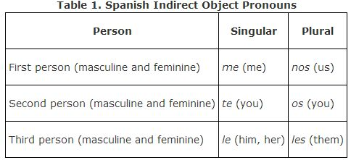

As discussed earlier, English pronouns are the same for both indirect and direct objects. You can see that most of the Spanish indirect object pronouns look exactly like direct object pronouns except for the third person singular and plural. There is no differentiation between the masculine indirect object pronoun to him and the feminine to her. The pronouns le/les are used as the indirect object pronoun for both genders.
Because the pronoun le has several meanings, a clarification should be placed either at the beginning of the sentence or after the verb to indicate the gender or even the specific person. To create a clarification, the preposition a is followed by a subject pronoun. A él, a ella, or a usted can be used to clarify the pronoun le, or any noun can be used after the preposition a to specify exactly who the indirect object is.
The pronoun les has the same problem, so if it's necessary to clarify the gender of “them” or to specify “you guys,” use the same method of clarification by adding a in front of the subject pronoun, as in a ellos, a ellas, or a ustedes.

Indirect object pronoun placement
In the following sample sentences, the actual indirect object and the indirect object pronoun are both in bold print because they both refer to the same thing. But unlike with direct objects, you do not have to eliminate the indirect object to require a pronoun. You must use an indirect object pronoun any time there is an indirect object, but you may choose to use only the indirect object pronoun if the actual indirect object is clear. The indirect object pronoun is placed before the conjugated verb or attached to an infinitive like a direct object. The clarification is provided in Spanish by using the preposition a + noun or personal subject pronoun.

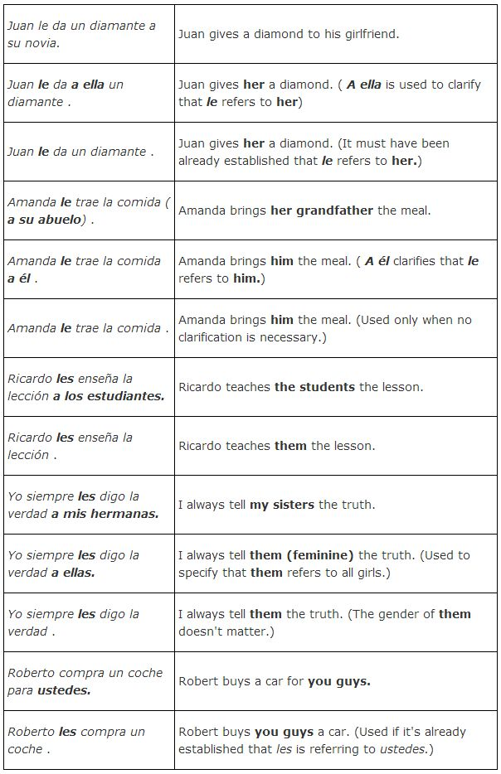

Notice in these examples that you can use either the indirect object pronoun without the actual indirect object stated or the indirect object pronoun along with the actual indirect object. Note: In Spanish, you cannot sayDoy el dinero a ella. You must use the indirect object pronoun: Le doy el dinero (a ella).

Special verbs with indirect object pronouns

There are a few special verbs that work in conjunction with an indirect object pronoun to create an idiomatic expression that is quite common in Spanish as well as its English equivalent. See if you know the meanings of the following sentences.

Me gusta la pizza. Te gustan los libros. Nos gusta la música. Le gusta bailar.
You probably translate the first sentence as “I like pizza,” and you are correct. “I like” is the idiomatic expression used in English to express “me gusta,” but in reality the verb gustar means to please, and the Spanish expression states “Pizza pleases me.” Notice that yo is never used with a gustar‐type verb. It's easier to use the verb gustar correctly if you understand that it doesn't exactly mean “like” even though you translate it that way. When you learn the patterns of sentences with the verb gustar, you will also be able to use the verbs in Table 2, because they are all used in sentences exactly like gustar.
These sentences are tricky, because the English version uses a subject pronoun and the Spanish version uses an indirect object pronoun. Try reading the Spanish sentence backward and it will be more like the English version.

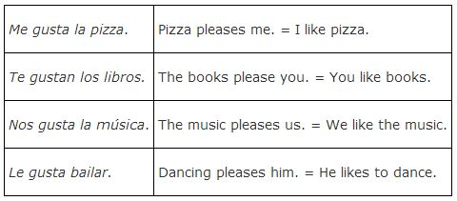

Because the pronoun le is so vague, a clarification can be placed either at the beginning of the sentence or after gustar to indicate the gender or even the specific person who is pleased. To create a clarification, use the preposition a followed by a subject pronoun. A él, a ella, or a usted can be used to clarify the pronoun le.

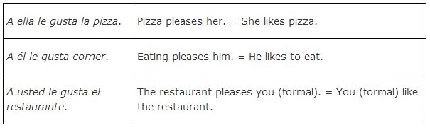
The pronoun les has the same problem, so if it is necessary to clarify the gender of “them” or to specify “you guys,” use the same method of clarification by adding a ellos, a ellas, or a ustedes.

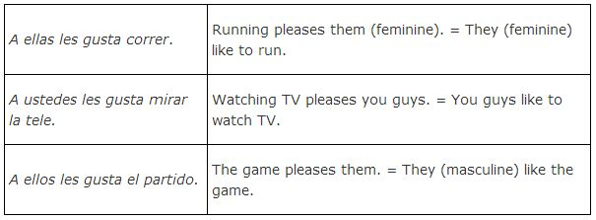

The indirect object precedes the verb gustar to indicate who is pleased. But what makes these sentences stray from the Spanish norm, is that the subject of the sentence—the thing that is doing the pleasing—follows the verb. The verb is still conjugated to go with the subject, but the subject is after the verb. Usually either the él or ellos form of gustar (gusta) is used. Gustan is used when followed by a plural subject, and gusta is used when followed by a singular subject or an infinitive. The indirect object that precedes gusta or gustan does not affect which form of gustar you use. Look carefully at the following examples, and notice that gustar is conjugated to go with the subject that follows. If there is a clarification of the indirect object after gustar, ignore it. The subject follows and determines which form of gustar to use.

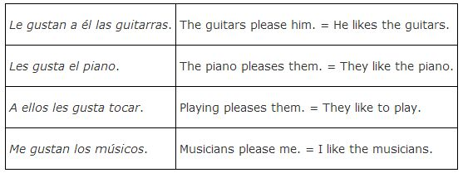

When gusta is followed by a verb in its infinitive form, the verb is actually acting like a singular noun and is called a gerund. In English, a verb that is acting like a noun will have the –ing ending, but in Spanish the infinitive is always used in those cases.

Soccer is fun. Playing is fun.
Both soccer and playing are singular nouns, as are fútbol and jugar in this translation:
El fútbol es divertido. Jugar es divertido.
So when an infinitive is used as the subject after gustar, the él form gusta is appropriate, as in these examples:
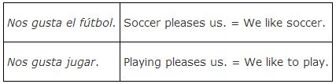

There are several common verbs in Spanish that are used exactly like gustar, as shown in Table 3 . It's important to learn these verbs and the examples that follow in order to use them correctly.
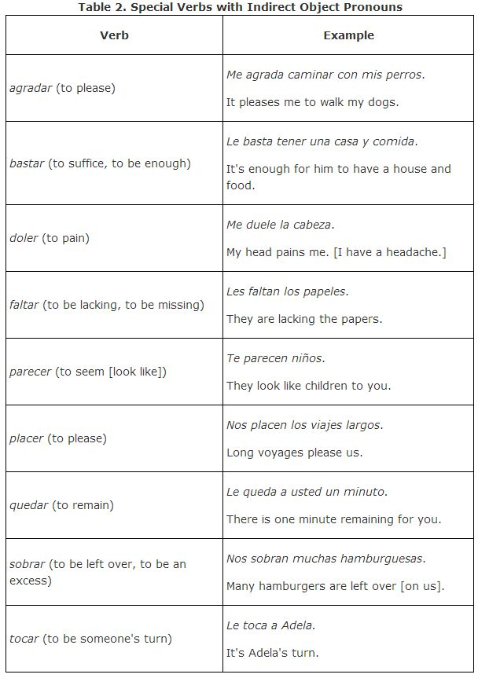
Choose the appropriate indirect object pronoun to fill in the blank.

Da___ las llaves *a mí*.
- 1
me
- 2
nos
- 3
te
- 4
les
- 5
os
María ___ va a escribir una carta *a usted*.
- 1
les
- 2
te
- 3
le
- 4
os
- 5
nos
___ dije la verdad *a ti*.
- 1
Te
STREAK x3
- 2
Me
- 3
Les
- 4
Le
- 5
Le
___ contó el cuento *a nosotros*.
- 1
Les
- 2
Te
- 3
Me
- 4
Nos
STREAK x4
- 5
Le
Pedro ___ dio la pluma *a mí*.
- 1
te
- 2
me
STREAK x5
- 3
nos
- 4
os
- 5
te
___ pido silencio *a los alumnos*.
- 1
Me
- 2
Les
STREAK x6
- 3
Le
- 4
Te
- 5
Os
___ envió una carta *a los padres*.
- 1
Me
- 2
Le
- 3
Nos
- 4
Te
- 5
Les
STREAK x7
¿Por qué siempre ___ esconden la verdad *a sus padres*?
- 1
me
- 2
le
- 3
les
STREAK x8
- 4
nos
- 5
os
Rosa ___ compra el vestido rojo *a tí*.
- 1
Le
- 2
Me
- 3
Te
STREAK x9
- 4
Os
- 5
Nos
No ___ voy a prestar mi coche *a mis vecinos*.
- 1
le
- 2
nos
- 3
les
STREAK x10
- 4
os
- 5
te
___ doy el regalo *a los vecinos*.
- 1
Os
- 2
Me
- 3
Nos
- 4
Les
STREAK x11
- 5
Le
___ enviamos el mensaje *a vosotros*.
- 1
Te
- 2
Les
- 3
Os
STREAK x12
- 4
Nos
- 5
Le
Cada mañana ___ compro pan *a ustedes*.
- 1
te
- 2
les
STREAK x13
- 3
os
- 4
me
- 5
le
*A él* ___ voy a mostar mi carro nuevo.
- 1
te
- 2
nos
- 3
le
STREAK x14
- 4
les
- 5
me
Raúl ___ dio el dinero *a ti*.
- 1
me
- 2
os
- 3
le
- 4
te
STREAK x15
- 5
nos
___ mostraron sus pasaportes *a nosotros*.
- 1
Nos
STREAK x16
- 2
Me
- 3
Les
- 4
Te
- 5
Os
¿___ devolviste el libro *a tus padres*?
- 1
Os
- 2
Les
STREAK x17
- 3
Me
- 4
Le
- 5
Nos
Los estudiantes ___ dan sus informes orales *a ustedes*.
- 1
os
- 2
nos
- 3
le
- 4
les
STREAK x18
- 5
me
___voy a regalar unos aretes *a la profesora*.
- 1
Nos
- 2
Te
- 3
Me
- 4
Les
- 5
Le
___ tiró el balón *a él*.
- 1
Te
- 2
Les
- 3
Os
- 4
Le
STREAK x20
- 5
Me
___ da un anillo *a Rebeca*.
- 1
Nos
- 2
Les
- 3
Te
- 4
Le
STREAK x21
- 5
Me
Siempre ___ digo la verdad *a vosotros*.
- 1
te
- 2
os
STREAK x22
- 3
nos
- 4
me
- 5
les
___ voy a explicar las reglas *a ti*.
- 1
Le
- 2
Te
STREAK x23
- 3
Me
- 4
Les
- 5
Nos
No ___ prometo *a ti* una vida sin problemas.
- 1
nos
- 2
le
- 3
os
- 4
te
STREAK x24
- 5
me
___ dio el regalo *a Anita*.
- 1
Le
STREAK x25
- 2
Te
- 3
Me
- 4
Nos
- 5
Les
___ dio un regalo *a su hermano*.
- 1
Os
- 2
Te
- 3
Me
- 4
La
- 5
Le
Mi amiga ___ sugiere el traje de baño *a mí*.
- 1
les
- 2
le
- 3
me
STREAK x27
- 4
te
- 5
nos
___ enviamos el regalo *a ti* .
- 1
Nos
- 2
Le
- 3
Les
- 4
Me
- 5
Te
No ___ traigan los libros *a ellos*.
- 1
nos
- 2
me
- 3
les
STREAK x29
- 4
os
- 5
le
El maestro ___ explicó la lección *a nosotros*.
- 1
les
- 2
me
- 3
nos
STREAK x30
- 4
os
- 5
le
No ___ hables tan fuerte *a mí*.
- 1
les
- 2
me
STREAK x31
- 3
te
- 4
os
- 5
nos
¿___ diste tu número de teléfono *a Ernesto*?
- 1
Me
- 2
nos
- 3
Te
- 4
Le
STREAK x32
- 5
Les
___ tiene mucho cariño *a su perro*.
- 1
Te
- 2
Me
- 3
Nos
- 4
Le
STREAK x33
- 5
Les
___ escribí una tarjeta postal *a Elena*.
- 1
Les
- 2
Me
- 3
Nos
- 4
Te
- 5
Le
STREAK x34
___ tiran la pelota *a nosotros*.
- 1
Le
- 2
Te
- 3
Nos
STREAK x35
- 4
Les
- 5
Os
Quiero enseñar___ algo *a ustedes*.
- 1
me
- 2
les
STREAK x36
- 3
nos
- 4
le
- 5
os
___ compró el periódico para *la profesora*.
- 1
Nos
- 2
Les
- 3
Le
STREAK x37
- 4
Te
- 5
Me
Juan ___ escribió una carta *a ellos*.
- 1
le
- 2
nos
- 3
os
- 4
me
- 5
les
STREAK x38
¿Por qué no ___ quieres decir la verdad *a mí*?
- 1
te
- 2
os
- 3
le
- 4
me
STREAK x39
- 5
nos
___ traes una taza de té *a mí*.
- 1
Les
- 2
Te
- 3
nos
- 4
Le
- 5
Me

Choose the sentence below that best demonstrates the appropriate use of the indirect object pronoun.
Susana _____ compra la camisa para mí.
- Susana le compra la camisa para mí.
- Susana me compra la camisa para mí.
- Susana nos compra la camisa para mí.
Yo _____ mando las cartas a mi novio.
- Yo me mando las cartas a mi novio.
- Yo les mando las cartas a mi novio
- Yo le mando las cartas a mi novio.

Beatriz y Maruja _____ envían los regalos a nosotros.
- Beatriz y Maruja nos envían los regalos a nosotros.
- Beatriz y Maruja os envían los regalos a nosotros.
- Beatriz y Maruja les envían los regalos a nosotros.

Margarita y Marisol _____ escriben las tarjetas a los amigos.
- Margarita y Marisol me escriben las tarjetas a los amigos.
- Margarita y Marisol os escriben las tarjetas a los amigos.
- Margarita y Marisol les escriben las tarjetas a los amigos.
A ti _____ gusta cantar y bailar.
- A ti te gusta cantar y bailar.
- A ti le gusta cantar y bailar.
- A ti les gusta cantar y bailar.
A mí _____ duelen los pies.
- A mí les duelen los pies.
- A mí le duelen los pies.
- A mi me duelen los pies
A Fernando _____ gusta jugar al fútbol.
- A Fernando te gusta jugar al fútbol.
- A Fernando me gusta jugar al fútbol.
- A Fernando le gusta jugar al fútbol.
Ignacio _____ da la pelota a la niña. =
- Ignacio le da la pelota a la niña.
- Ignacio les da la pelota a la niña.
- Ignacio me da la pelota a la niña.

Mi hermano _____ pasa el plato a Felipe. =
- Mi hermano les pasa el plato a Felipe.
- Mi hermano le pasa el plato a Felipe.
- Mi hermano me pasa el plato a Felipe.
Lupita _____ dice la verdad a su mamá. =
- Lupita te dice la verdad a su mamá.
- Lupita le dice la verdad a su mamá.
- Lupita nos dice la verdad a su mamá.

Correct each sentence by replacing the indirect object phrase with the appropriate indirect object pronoun.
Jessica, on the ones with two possible ways of writing it, can you include both so they have to fill it in both ways? The highlighted words are the answers, but in the question, they will be replaced by blanks.

Eliza vende su coche a Roberto.
Eliza le vende su coche a Roberto.

No quiso pagar la cuenta al camarero.
No le quiso pagar la cuenta. o No quiso pagarle la cuenta al camarero.

Quiero explicar algo a ella.
Le quiero explicar algo a ella. Quiero explicarle algo a ella.

Dice unas mentiras a su madre.
Le dice unas mentiras a su madre.

Están sirviendo la mesa para ti.
Te están sirviendo la mesa para ti.
Están sirviéndote la mesa para ti.

Digo la verdad al chico.
Le digo la verdad al chico.

Necesito escribir una carta a Pedro.
Le necesito escribir una carta a Pedro.
Necesito escribirle una carta a Pedro.

No quiere contar la verdad a ella.
No le quiere contar la verdad a ella.
No quiere contarle la verdad a ella.

¿Quién va a dar un regalo a la novia y el novio?
¿Quién les va a dar un regalo a la novia y el novio?
¿Quién va a darles un regalo a la novia y el novio?

Dio el libro al profesor.
Le dio el libro al profesor.

Tienes que leer este libro a ella.
Le tienes que leer este libro a ella.
Tienes que leerle este libro a ella.

Mostré las fotos a María.
Le mostré las fotos a María.

Ann da el dinero a nosotros.
Ann nos da el dinero a nosotros.

Tendí la mano a mi hermanita.
Le tendí la mano a mi hermanita.

Va a contar su decisión a nosotros.
Nos va a contar su decisión a nosotros.
Va a contarnos su decisión a nosotros.

Mi amiga dijo una mentira a mí.
Mi amiga me dijo una mentira a mí.

No va a mandar flores a ellas.
No les va a mandar flores a ellas.
No va a mandarles flores a ellas.

Va a escribir una carta a nosotros.
Nos va a escribir una carta a nosotros.
Va a escribirnos una carta a nosotros.

Dio un consejo al niño.
Le dio un consejo al niño.

No tengo que decir nada a mis padres.
No les tengo que decir nada a mis padres.
No tengo que decirles nada a mis padres.

Envié invitaciones para la fiesta a vosotros.
Os envié invitaciones para la fiesta a vosotros.

¿Quiere alquilar su apartamento a vosotros?
¿Os quiere alquilar su apartmante a vosotros?
¿Quiere alquilaros su apartamento a vosotros?

Tiré la pelota al perro.
Le tiré la pelota al perro.

No vendas la cerveza a nosotros.
No nos vendas la cerveza a nosotros.

Traje para ti la flor.
Te traje para ti la flor.

Preparamos la cena para mis padres.
Les preparamos la cena para mis padres.

Tengo una sorpresa para ti.
Te tengo una sorpresa para ti.

Tienes que dar este libro a mí.
Me tienes que dar este libro a mí.
Tienes que darme este libro a mí.

Ella quiere entregar sus joyas a mí.
Ella me quiere entregar sus joyas a mí.
Ella quiere entregarme sus joyas a mí.

Voy a mandar abrazos para ti.
Te voy a mandar abrazos para ti.
Voy a mandarte abrazos para ti.

El niño dio los huesos al perro.
El niño le dio los huesos al perro.

No expliques tus razones a mí.
No me expliques tus razones a mí.

Lisa quiere decir un secreto a ti.
Lisa te quiere decir un secreto a ti.
Lisa quiere decirte un secreto a ti.

Tengo mucho respeto por ustedes.
Les tengo mucho respeto por ustedes.

Determine the direct object (DO) and the indirect object (IO). Write only the noun, not the article.
  - He gave her the ring.
DO= ring
  - He gave her the ring.
IO= her
  - He sang them a song.
DO= song
  - He sang them a song.
IO= them
  - Give the dog a bone.
DO= bone
  - Give the dog a bone.
IO= dog
- John didn't write Mary a letter.
DO= letter
- John didn't write Mary a letter.
IO= Mary
- Don't bring me any coffee.
DO= coffee
- Don't bring me any coffee.
IO= me
- Don't tell me the truth.
DO= truth
- Don't tell me the truth.
IO= me

Choose the correct pronoun.
  - Juan compra flores para ella.
Juan le compra flores.
  - El mesero da el menú a ellos.
El mesero les da el menú.
  - Ellos dan una propina a mí.
Ellos me dan una propina.
  - Compro el libro para ti.
Te compro el libro.

Fill in the blank in order to form translations that are true and correct.
  - He wants to give me the money.
Él me quiere dar el dinero.
  - He wants to give me the money.
Él quiere darme el dinero.
  - They want to give her something.
Ellos le quieren dar algo.
  - They want to give her something.
Ellos quieren darle algo.
  - You need to buy us the house.
Nos necesitas comprar la casa.
  - You need to buy us the house.
Necesitas comprarnos la casa.
  - We want to sell them the car.
Les queremos vender el auto.
  - We want to sell them the car.
Queremos venderles el auto.
  - Andrea wants to sell me the book.
Andrea me quiere vender el libro.
  - Andrea wants to sell me the book.
Andrea quiere venderme el libro.

Fill in the blank in order to form sentences that are true and correct.
  - Debemos alquilar el apartamento a ellos.
Debemos alquilarles el apartamento.
  - Debemos alquilar el apartamento a ellos.
Les debemos alquilar el apartamento.
  - Juan tiene que prestar el dinero a mí.
Juan tiene que prestarme el dinero.
  - Juan tiene que prestar el dinero a mí.
Juan me tiene que prestar el dinero.

Translate the following negative sentences.
  - I don't have to tell her anything.
No tengo que decirle nada.
  - I don't have to tell her anything.
No le tengo que decir nada.
  - She can never buy me the car.
Ella nunca puede comprarme el auto.
  - She can never buy me the car.
Ella nunca me puede comprar el auto.
  - They don't want to sell you the house. (use the tú form)
Ellos no quieren venderte la casa.
  - They don't want to sell you the house. (use the tú form)
Ellos no te quieren vender la casa.

